GENERATION OF ODD NUMBERS

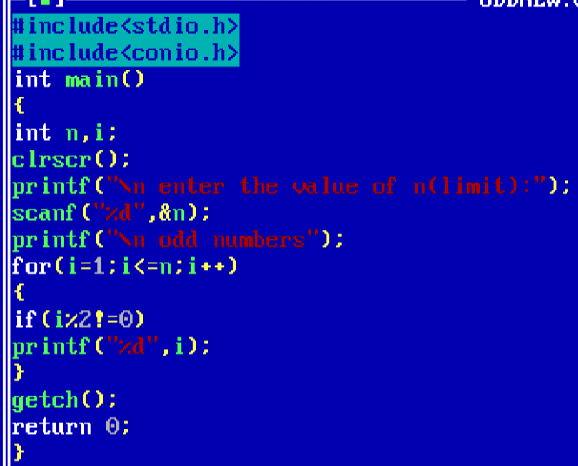

OUTPUT

